**ROLL NO:2031004**

**NAME: Akshaya V T**

**BACK END:**

**You need to create a REST service that can fetch bank details, using the data given in the API’s query parameters. You can use the data available in this** [**Link**](https://imageuploadtestingbob.s3.us-east-2.amazonaws.com/dev/backend-intern/bank_branches.csv) **in your backend DB**

**Used PostgreSQL for database.**

**Output screen shots:**

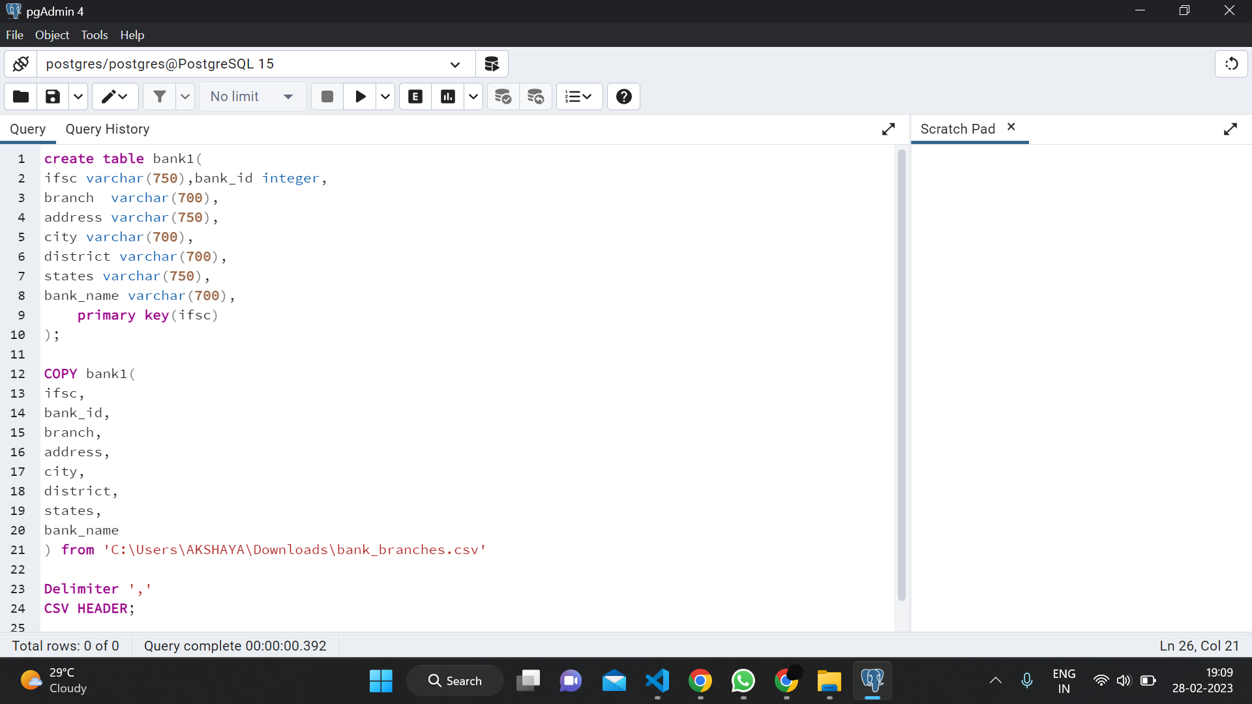**Table creation:**

**CASE 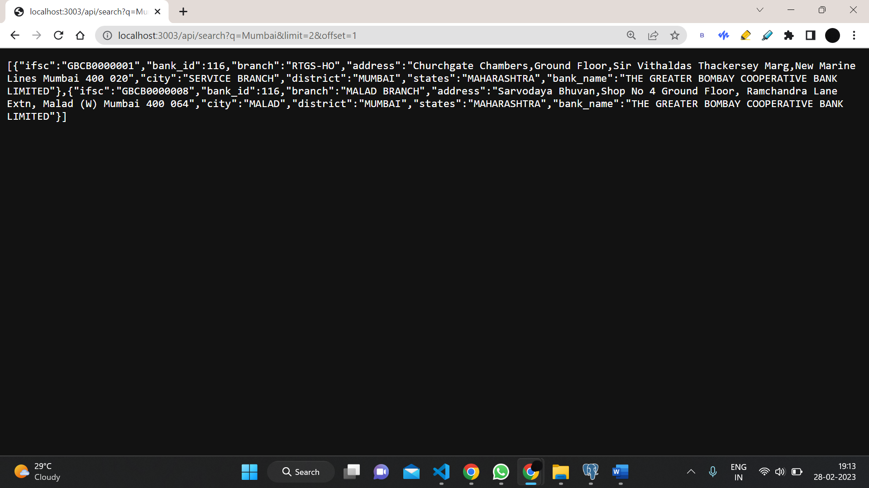1**

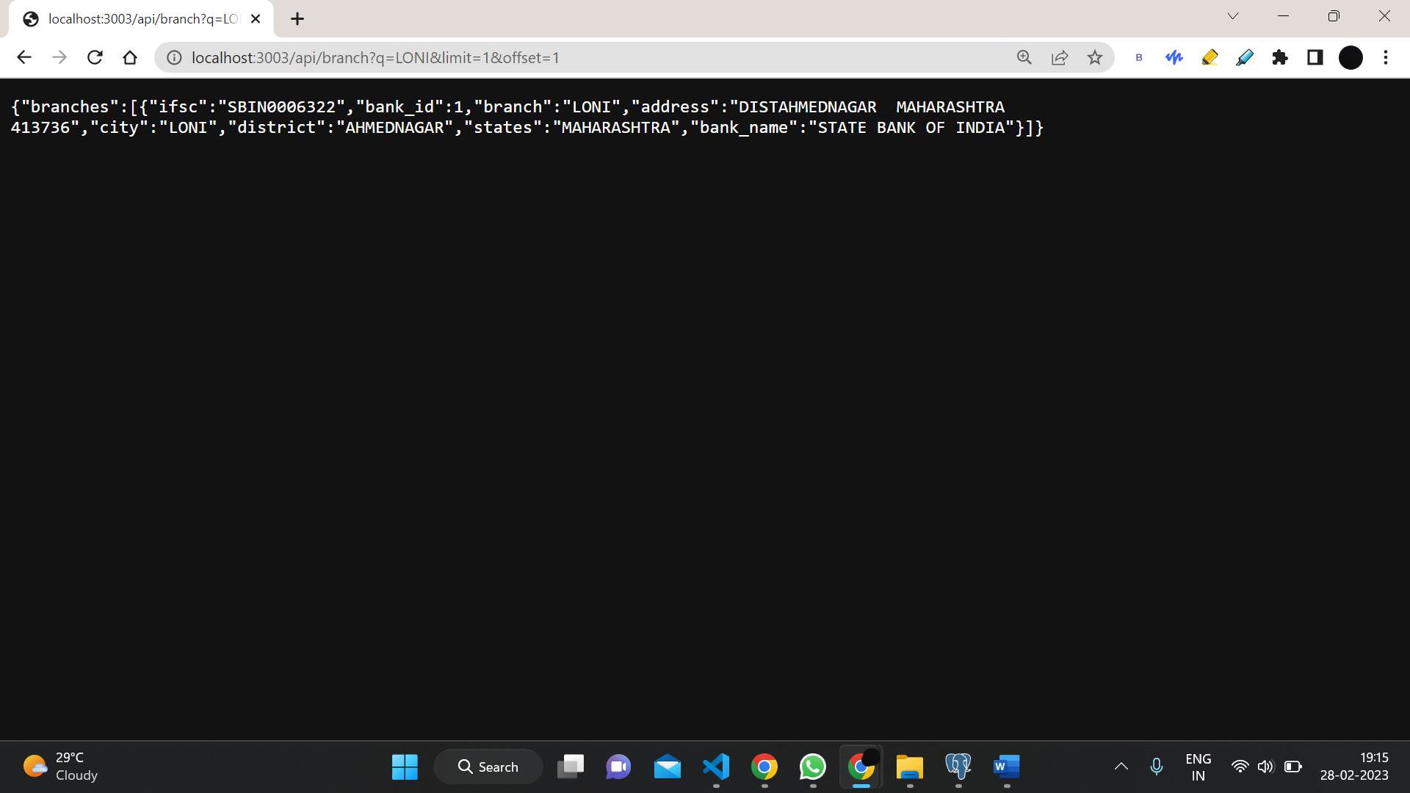

**CASE 2**